# Build an SMA-based Signal Strategy

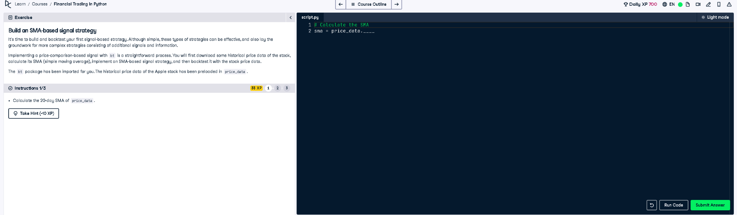

## Full Python Answer

# Calculate the SMA (Simple Moving Average)  
sma = price_data.rolling(window=20).mean()

## Explanation in Simple Words

The task asks us to calculate the 20-day Simple Moving Average (SMA) of the stock prices in the variable `price_data`. This is done using a moving window of 20 days, which smooths out price trends. It helps identify signals in trading strategies like when to buy or sell.